**PRACTICAL FILE**

LAB 1

|  |
| --- |
| <!DOCTYPE html> |
|  | <html lang="en" dir="ltr"> |
|  | <head> |
|  | <meta charset="utf-8"> |
|  | <title>Register</title> |
|  | </head> |
|  | <body> |
|  | <center><h1>REGISTRATION FORM</h1></center> |
|  | <h5><time></time></h5> |
|  | <feildset> |
|  | <form action="meta.html" method="post" autocomplete="on"> |
|  | <!--hidden input type contains hidden information that will also be processed in action browser--> |
|  | <input type="hidden" name="recipient" value=""> |
|  | <input type="hidden" name="subject" value=""> |
|  | <input type="hidden" name="redirect" value=""> |
|  | <!--input type text inserts a text feild to be input by user--> |
|  |  |
|  | <p><feildset><label>First Name: |
|  | <input type="text" placeholder="First Name" id="firstname"name="name" size="25" maxlength="30"> |
|  | </label>(First name)</feildset></p> |
|  |  |
|  | <p><label>Last Name: |
|  | <input type="text" placeholder="Last Name" id="lastname"name="name" size="25" maxlength="30"> |
|  | </label>(Last name)</p> |
|  | <p> |
|  | <label>Date: |
|  | <input type="date"/> |
|  | (yyyy-mm-dd) |
|  | </label> |
|  | </p> |
|  | <p><label>E-mail address: |
|  | <input type="email" name="details" placeholder="name@domain.com" required></label> |
|  | </p> |
|  | <p><label>Phone Number |
|  | <input type="tel" name="details" placeholder="##########" pattern="\d{10}" required></label> |
|  | </p> |
|  | <p> |
|  | <label>Datetime Local: |
|  | <input type="datetime-local"/> |
|  | (yyyy-mm-ddThh:mm, such as 2012-01-27T03:15) |
|  | </label> |
|  | </p> |
|  | <p> |
|  | <label for="txtList">Qualifications: |
|  | <input type="text" id="txtList" placeholder="Qualifications" list="Qualifications"> |
|  | <datalist id="Qualifications"> |
|  | <option value="Matric"> |
|  | <option value="High School"> |
|  | <option value="UG"> |
|  | <option value="PG"> |
|  | </datalist> |
|  | </label> |
|  | </p> |
|  | <p> |
|  | <strong>Team you liked</strong><br> |
|  | <label>Programming team |
|  | <input type="checkbox" name="teamselection" value="programming"> |
|  | </label> |
|  | <label>Creative team |
|  | <input type="checkbox" name="teamselection" value="creative"> |
|  | </label> |
|  | <label>Mulltimedia team |
|  | <input type="checkbox" name="teamselection" value="multimedia"> |
|  | </label> |
|  | <label>Testing team |
|  | <input type="checkbox" name="teamselection" value="testing"> |
|  | </label> |
|  | </p> |
|  | <p> |
|  | <strong>Confirm</strong> |
|  | <label>Yes |
|  | <input type="radio" name="confirmation" value="yes" checked> |
|  | </label> |
|  | <label>No |
|  | <input type="radio" name="confirmation" value="no"> |
|  | <!--name class must be same in a given paragraph--> |
|  | </label> |
|  | </p> |
|  | <p> |
|  | <label>Rate our site |
|  | <select name="rating"> |
|  | <option selected>Amazing</option> |
|  | <option>10</option> |
|  | <option>9</option> |
|  | <option>8</option> |
|  | <option>7</option> |
|  | <option>6</option> |
|  | <option>5</option> |
|  | <option>4</option> |
|  | <option>3</option> |
|  | <option>2</option> |
|  | <option>1</option> |
|  | <option>Awful</option> |
|  | </select> |
|  | </label> |
|  | </p> |
|  | <p> |
|  | <label> |
|  | Comments<br> |
|  | <textarea name="comments" rows="4" cols="40">Enter your comment</textarea> |
|  | </label> |
|  | </p> |
|  | <p> |
|  | <input type="submit" value="Submit"> |
|  | <input type="reset" value="Clear"> |
|  | </p> |
|  | </form> |
|  | </feildset> |
|  | </body> |
|  | </html> |

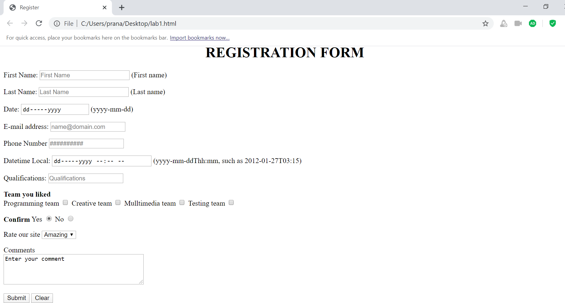

LAB 2

|  |
| --- |
| <!DOCTYPE html PUBLIC "-//W3C//DTD XHTML 1.1//EN" |
|  | "http://www.w3.org/TR/xhtml11/DTD/xhtml11.dtd"> |
|  | <html lang="en" dir="ltr"> |
|  | <head> |
|  | <title>Registration Form</title> |
|  | <link rel="stylesheet" href="style.css"> |
|  | </head> |
|  | <body> |
|  | <div class="ab"> |
|  | <h1>Create Your Account</h1></div> |
|  |  |
|  | <div> |
|  | <div class="dv"> |
|  | <form method="post"> |
|  | <table width="50%"> |
|  | <th><label>First Name</label> |
|  | <input type="text" placeholder="Enter your Firstname here"></th> |
|  | <th><label for="">Last Name</label> |
|  | <input type="text" placeholder="Enter your Lastname here"></th> |
|  | </table> |
|  | <br> |
|  | <br> |
|  | <div> |
|  | <label class="abc"><b>E-mail:</b></label> |
|  | <br> |
|  | <input type="email" placeholder="Enter your email here"> |
|  | <br> |
|  | <br> |
|  | <br> |
|  | <br> |
|  | <label class="abc"><b>Gender:</b></label> |
|  | <input type="radio" name="ab" value="male">Male |
|  | <input type="radio" name="ab" value="female">Female |
|  | <input type="radio" name="ab" value="others">Others |
|  | <br> |
|  | <br> |
|  | <br> |
|  | <br> |
|  | <label class="abc"><b>Mobile No:</b></label><br> |
|  | <table width="50%"> |
|  | <th> |
|  | <select > |
|  | <option>Select</option> |
|  | <option>+91</option> |
|  | <option>+310</option> |
|  | <option>+55</option> |
|  | <option>+1</option> |
|  | <option>+355</option> |
|  | <option>+2</option> |
|  | </select></th> |
|  | <th> |
|  | <input type="text" placeholder="Enter your Mobile number "></th> |
|  | </table> |
|  | </div> |
|  | <hr> |
|  | <table width="30%"> |
|  | <th><input type="submit" value="Register"></th> |
|  | <th><input type="reset" value="Clear"></th> |
|  | </table> |
|  | </form> |
|  | </div> |
|  | </div> |
|  | </body> |
|  | </html> |

|  |
| --- |
| .dv{ background-color:Lightgrey; |
|  | margin: 0px 300px 300px 300px;} |
|  | .abc{margin-left: 60px;} |
|  | input[type=email]{width:50%; |
|  | margin-left: 60px; |
|  | } |
|  | body{background-color:white} |
|  | .ab{text-align: center; |
|  | text-shadow: 5px; |
|  | padding: 2px; |
|  | margin: auto;} |

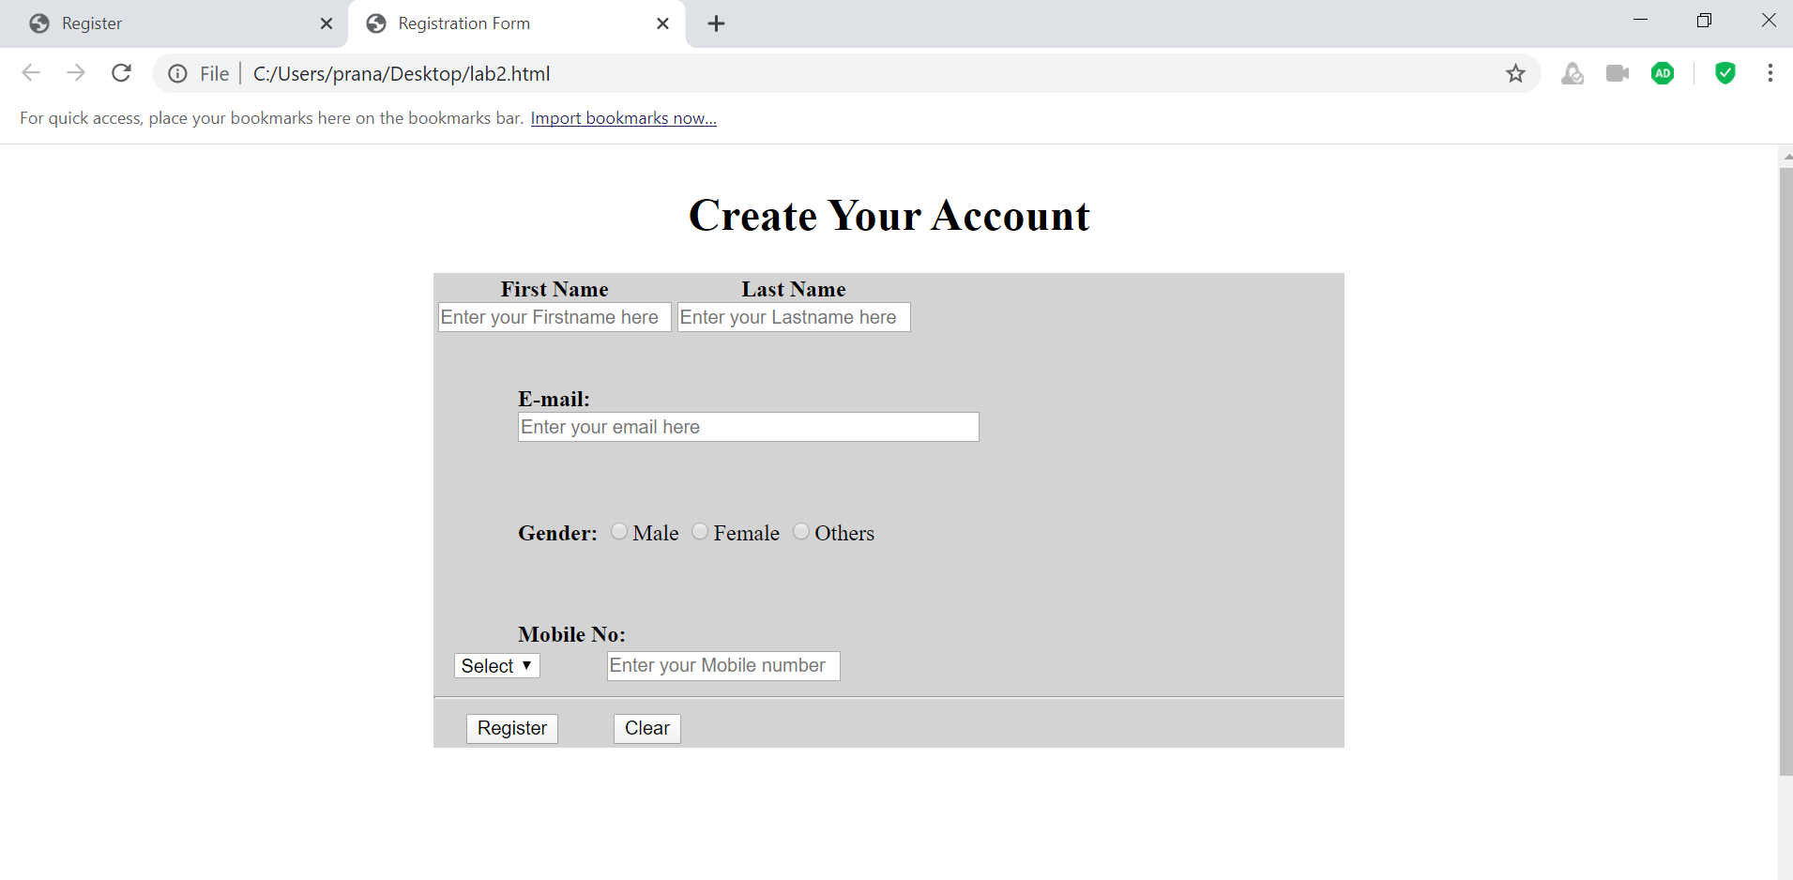

LAB 3

|  |
| --- |
| <!DOCTYPE html> |
|  | <html lang="en" dir="ltr"> |
|  | <head> |
|  | <meta charset="utf-8"> |
|  | <title>Cascading Style Sheets</title> |
|  | <style media="screen" type="text/css"> |
|  | body |
|  | { |
|  | background-color: lightpink; |
|  | //background-image: url(img1.png); |
|  | // background-repeat: no-repeat; |
|  | // background-size: contain; |
|  | } |
|  | p |
|  | { |
|  | padding-top:10pt; |
|  | paddind-bottom:10pt; |
|  | text-indent: 1em; |
|  | } |
|  | em |
|  | { |
|  | font-weight : normal; |
|  | color : #6F0F0F; |
|  | } |
|  | h1 |
|  | { |
|  | font-family : tahoma,san-serif,helvetica; |
|  | border-bottom:2px dotted blue; |
|  | } |
|  | p |
|  | { |
|  | font-size : 12pt; |
|  | font-family : san-serif,arial; |
|  | } |
|  | .special |
|  | { |
|  | color : purple; |
|  | } |
|  | a |
|  | { |
|  | text-decoration:none; |
|  | } |
|  | a:hover |
|  | { |
|  | text-decoration: underline; |
|  | font-weight:bold; |
|  | color:green; |
|  | } |
|  | a:visited |
|  | { |
|  | color:hotpink; |
|  | } |
|  | a:active |
|  | { |
|  | background-color:rgba(126, 0, 0, 0.4); |
|  | } |
|  | li |
|  | { |
|  | margin-left: 40px; |
|  | } |
|  | aside |
|  | { |
|  | font-size: .8em; |
|  | float:right; |
|  | } |
|  | table |
|  | { |
|  | border-collapse: collapse; |
|  | border-style:outset; |
|  | } |
|  | </style> |
|  | </head> |
|  | <body> |
|  | <h1 class="special"><center>Cascading Style Sheets(CSS3)</center></h1> |
|  | <a href="#W3C">Go to W3C</a> |
|  | <h3>WHAT IS CSS3?</h3> |
|  | <p>Formatting and presentation of any HTML document is done by using cascading style sheets(CSS3).</p> |
|  | <p style="font-size: 18pt;">The th\ree way of using CSS3 are : </p> |
|  | <ul> |
|  | <li>INLINE STYLING</li> |
|  | <li>EMBEDDED STYLE SHEETS</li> |
|  | <li>LINKING EXTERNAL STYLE SHEETS</li> |
|  | </ul> |
|  | <p>This page is to demonstrate the use of CSS3 in our HTML document. The CSS is used to style your html doc. file as it can be used in three ways by embedding it in your elememt tag the second way is to use the style element tag in the head of your HTML file and then calling the following tag for styling the last method is to create a seperate file of css and then linking it to yur html doc. file using link tag and href attribute. </p> |
|  | <p>The process of linking external style sheets to your HTML document is also known as skinning.</p> |
|  | <h3>Benefits of using CSS3</h3> |
|  | <ol> |
|  | <li>Improved control over formatting</li> |
|  | <li>Improves site maintainability</li> |
|  | <li>Improves page download speed</li> |
|  | <li>Improves output flexibility</li> |
|  | </ol> |
|  | <h3 >CSS3 Properties</h3> |
|  | <table border="1px" width="50%"> |
|  | <thead> |
|  | <td>Property Type</td> |
|  | <td>Property</td> |
|  | </thead> |
|  | <tr> |
|  | <td rowspan="5">FONTS</td> |
|  | <td>font-family</td> |
|  | </tr> |
|  | <tr> |
|  | <td>font-size</td> |
|  | </tr> |
|  | <tr> |
|  | <td>font-style</td> |
|  | </tr> |
|  | <tr> |
|  | <td>font-weight</td> |
|  | </tr> |
|  | <tr> |
|  | <td>font-face</td> |
|  | </tr> |
|  | <tr> |
|  | <td rowspan="5">TEXT</td> |
|  | <td>letter-spacing</td> |
|  | </tr> |
|  | <tr> |
|  | <td>line-height</td> |
|  | </tr> |
|  | <tr> |
|  | <td>text-align</td> |
|  | </tr> |
|  | <tr> |
|  | <td>text-decoration</td> |
|  | </tr> |
|  | <tr> |
|  | <td>text-indent</td> |
|  | </tr> |
|  | <tr> |
|  | <td rowspan="5">COLOR AND BACKGROUND</td> |
|  | <td>background-color</td> |
|  | </tr> |
|  | <tr> |
|  | <td>background-image</td> |
|  | </tr> |
|  | <tr> |
|  | <td>background-position</td> |
|  | </tr> |
|  | <tr> |
|  | <td>background-repeat</td> |
|  | </tr> |
|  | <tr> |
|  | <td>color</td> |
|  | </tr> |
|  | <tr> |
|  | <td rowspan="6">BORDERS</td> |
|  | <td>border-color</td> |
|  | </tr> |
|  | <tr> |
|  | <td>border-width</td> |
|  | </tr> |
|  | <tr> |
|  | <td>border-style</td> |
|  | </tr> |
|  | <tr> |
|  | <td>border-top</td> |
|  | </tr> |
|  | <tr> |
|  | <td>border-top-color</td> |
|  | </tr> |
|  | <tr> |
|  | <td>border-top-width</td> |
|  | </tr> |
|  | <tr> |
|  | <td rowspan="4">SPACING</td> |
|  | <td>padding</td> |
|  | </tr> |
|  | <tr> |
|  | <td>padding-top,padding-bottom,padding-right,padding-left</td> |
|  | </tr> |
|  | <tr> |
|  | <td>margin</td> |
|  | </tr> |
|  | <tr> |
|  | <td>margin-top,margin-bottom,margin-left,margin-right</td> |
|  | </tr> |
|  | <tr> |
|  | <td rowspan="5">SIZING</td> |
|  | <td>max-height</td> |
|  | </tr> |
|  | <tr> |
|  | <td>max-width</td> |
|  | </tr> |
|  | <tr> |
|  | <td>min-height</td> |
|  | </tr> |
|  | <tr> |
|  | <td>min-width</td> |
|  | </tr> |
|  | <tr> |
|  | <td>width</td> |
|  | </tr> |
|  | <tr> |
|  | <td rowspan="5">LAYOUTS</td> |
|  | <td>bottom,left,top and right</td> |
|  | </tr> |
|  | <tr>Overflow</tr> |
|  | <tr> |
|  | <td>position</td> |
|  | </tr> |
|  | <tr> |
|  | <td>visibility</td> |
|  | </tr> |
|  | <tr> |
|  | <td>z-index</td> |
|  | </tr> |
|  | <tr> |
|  | <td rowspan="3">LISTS</td> |
|  | <td>list-style</td> |
|  | </tr> |
|  | <tr> |
|  | <td>list-style-image</td> |
|  | </tr> |
|  | <tr> |
|  | <td>list-style-type</td> |
|  | </tr> |
|  | </table> |
|  | <h3>Applying style class</h3> |
|  | <p>To apply style class to specify the special style to a particular paragraph over a html document containing several paragraph element in the html document user shall declare the class attribute in that particular html element and then call it later in the embedded style sheet by using period(.)class. </p> |
|  | <details><summary>Psuedo Class</summary> |
|  | <p>Psuedo class gives you access to information that's not declared in the document, such as whether the mouse hovering over an element or whether the user previously clicked(visited) a particular hyperlink</p> |
|  | </details> |
|  | <h3>Measurement Unit in CSS</h3> |
|  | <p>You can classify the measurement in CSS3 in the following type :</p> |
|  | <ol> |
|  | <li>Relative : A pixel is a relative-length measuement- it varies in size, based on screen resolution. Other relative length includes em(which, as a measurement means the font's uppercase M height-the most frequently used font measurement), ex(the font's x-height-usually set to a lowercase x's heigth) and percentage(e.g., font-size:50%)</li> |
|  | <li>Absolute : They do not vary in size based on the system. These units are inches(in), centimeter(cm), millimeter(mm), point(pt; 1pt=1/72inches), and picas(pi; 1pc=12points)</li> |
|  | </ol> |
|  | <p>Whenever possible, use relative-length measurement. If you use absolute-length measurement, your document may not scale well on some client browsers(e.g., smartphones) </p> |
|  | <aside id="W3C"> |
|  | To ensure that your style sheets work in various web browsers, test them on many web browsers, and use the <a href="http://www.google.com" target="_blank">W3C CSS validator.</a> |
|  | </aside> |
|  | </body> |
|  | </html> |

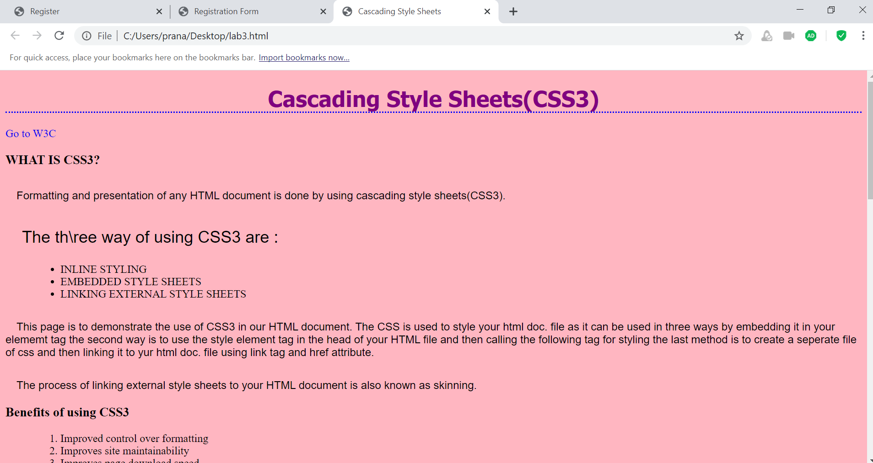

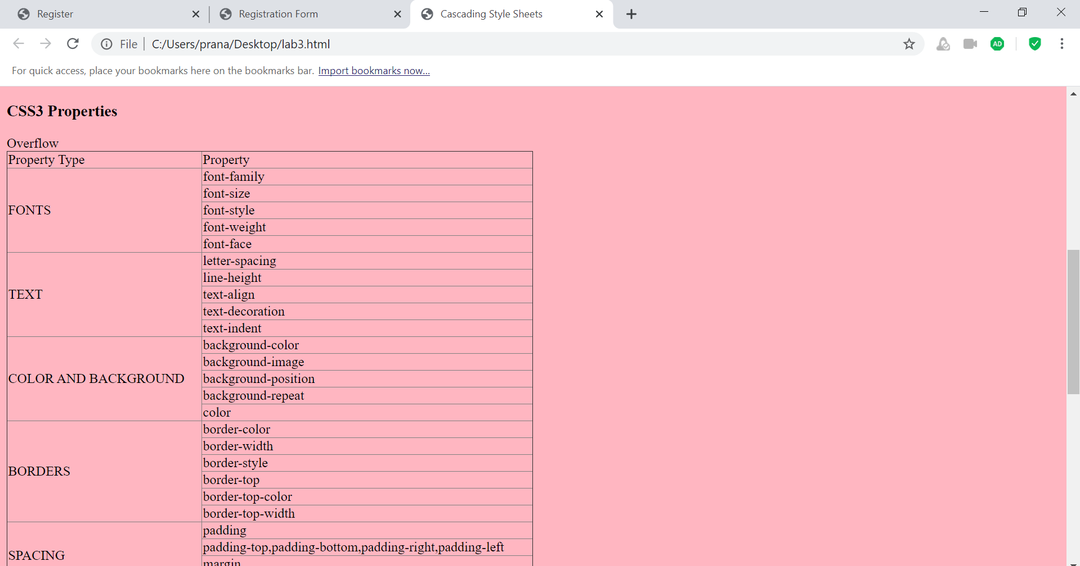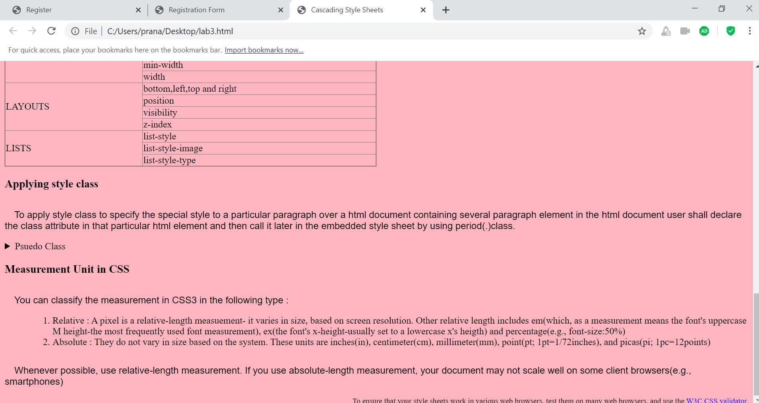

LAB 4

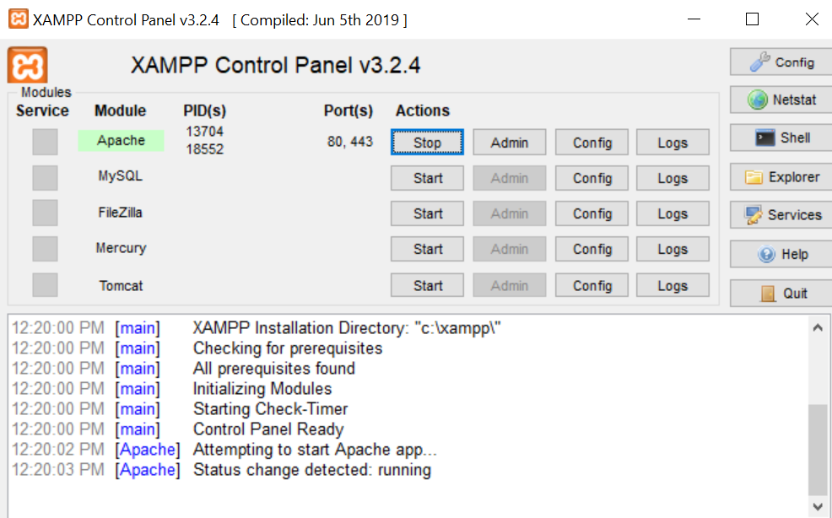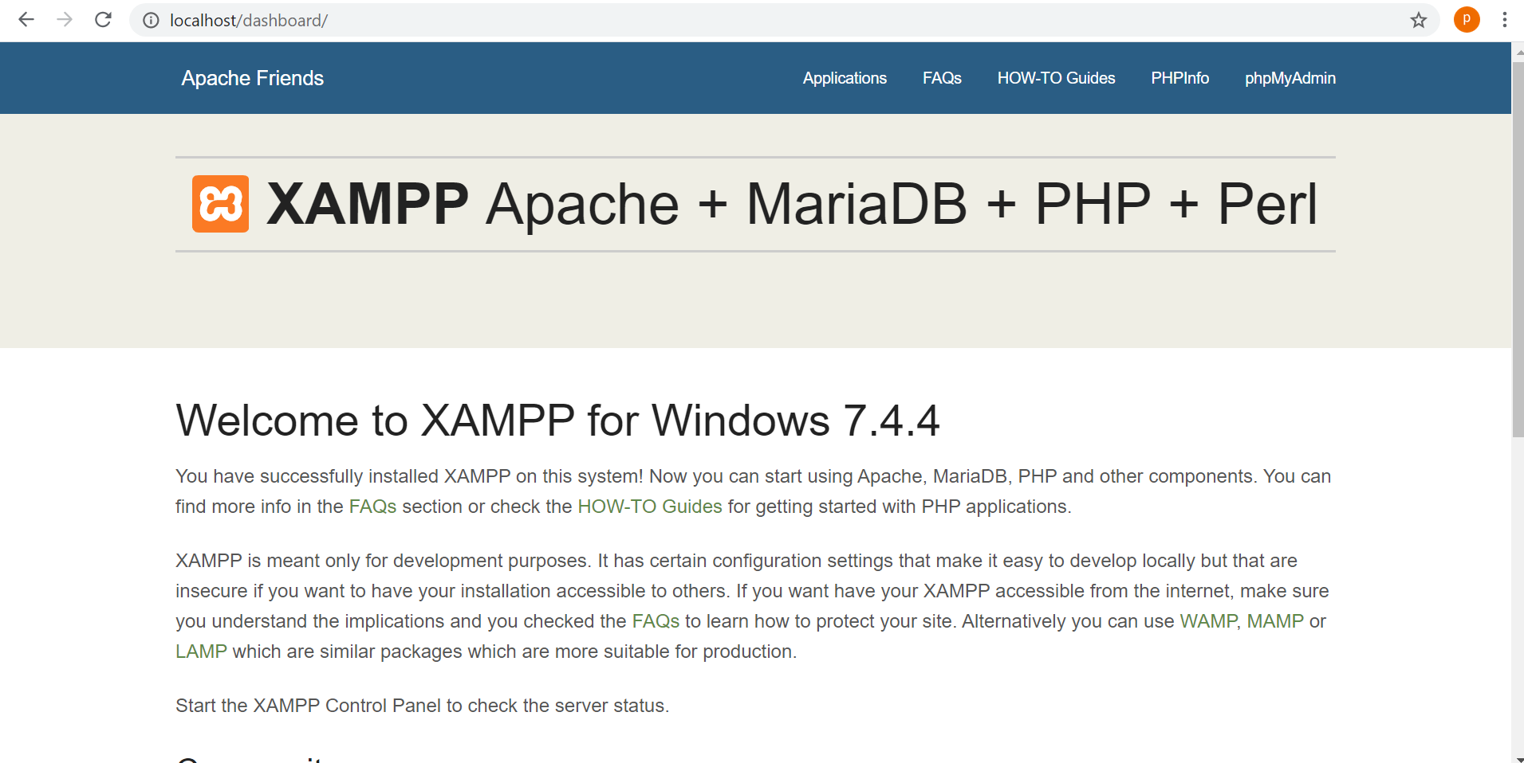

LAB 5

|  |
| --- |
| <html> |
|  | <head> |
|  | <title>prime check</title> |
|  | </head> |
|  | <body> |
|  | <?php |
|  | $num=8 |
|  | if($num==1) |
|  | echo "neither prime nor composite<br>"; |
|  | else{ |
|  | 4t=0; |
|  | for($i=2;$i<$num;$i++){ |
|  | if($num%$i==0) |
|  | $t++; |
|  | } |
|  | if($t==0) |
|  | echo "prime no<br>"; |
|  | else |
|  | echo "not prime<br>"; |
|  | } |
|  | ?> |
|  | </body> |
|  | </html>  Screenshot (71).png |

LAB 6

|  |
| --- |
| <html> |
|  | <head> |
|  | <meta charset="UTF-8"> |
|  | <meta name="viewport" content="width=device-width, initial-scale=1.0"> |
|  | <title>Website</title> |
|  | </head> |
|  | <body> |
|  | <?php |
|  |  |
|  | $name = $email = $gender = $comment = $website = ""; |
|  |  |
|  | if ($_SERVER["REQUEST_METHOD"] == "POST") { |
|  | $name = test_input($_POST["name"]); |
|  | $email = test_input($_POST["email"]); |
|  | $website = test_input($_POST["website"]); |
|  | $comment = test_input($_POST["comment"]); |
|  | $gender = test_input($_POST["gender"]); |
|  | } |
|  |  |
|  | function test_input($data) { |
|  | $data = trim($data); |
|  | $data = stripslashes($data); |
|  | $data = htmlspecialchars($data); |
|  | return $data; |
|  | } |
|  | ?> |
|  |  |
|  | <h2>PHP Form Validation Example</h2> |
|  | <form method="post" action="<?php echo htmlspecialchars($_SERVER["PHP_SELF"]);?>"> |
|  | Name: <input type="text" name="name"> |
|  | <br><br> |
|  | E-mail: <input type="text" name="email"> |
|  | <br><br> |
|  | Website: <input type="text" name="website"> |
|  | <br><br> |
|  | Comment: <textarea name="comment" rows="5" cols="40"></textarea> |
|  | <br><br> |
|  | Gender: |
|  | <input type="radio" name="gender" value="female">Female |
|  | <input type="radio" name="gender" value="male">Male |
|  | <input type="radio" name="gender" value="other">Other |
|  | <br><br> |
|  | <input type="submit" name="submit" value="Submit"> |
|  | </form> |
|  |  |
|  | <?php |
|  | echo "<h2>Check Your Entry:</h2>"; |
|  | echo $name; |
|  | echo "<br>"; |
|  | echo $email; |
|  | echo "<br>"; |
|  | echo $website; |
|  | echo "<br>"; |
|  | echo $comment; |
|  | echo "<br>"; |
|  | echo $gender; |
|  | ?> |
|  | </body> |
|  | </html>  Screenshot (72).png |

LAB 7

|  |
| --- |
| <!DOCTYPE html> |
|  | <html> |
|  | <head> |
|  | <title>Regular Expression</title> |
|  | <center> |
|  | <script type="text/javascript"> |
|  | function validate() |
|  | { |
|  | var username=document.getElementById("uname").value; |
|  | var regx=/A00/; |
|  | if(regx.test(username)) |
|  | { |
|  | alert("valid username"); |
|  | } |
|  | else |
|  | { |
|  | alert("Invalid username"); |
|  | } |
|  | } |
|  | </script> |
|  | </center> |
|  | </head> |
|  | <body> |
|  | <form action="message.html"> |
|  | <input type="text" id="uname" placeholder="username"/> |
|  | <button onclick="validate()">Submit</button> |
|  | </form> |
|  |  |
|  | </body> |
|  | </html> |

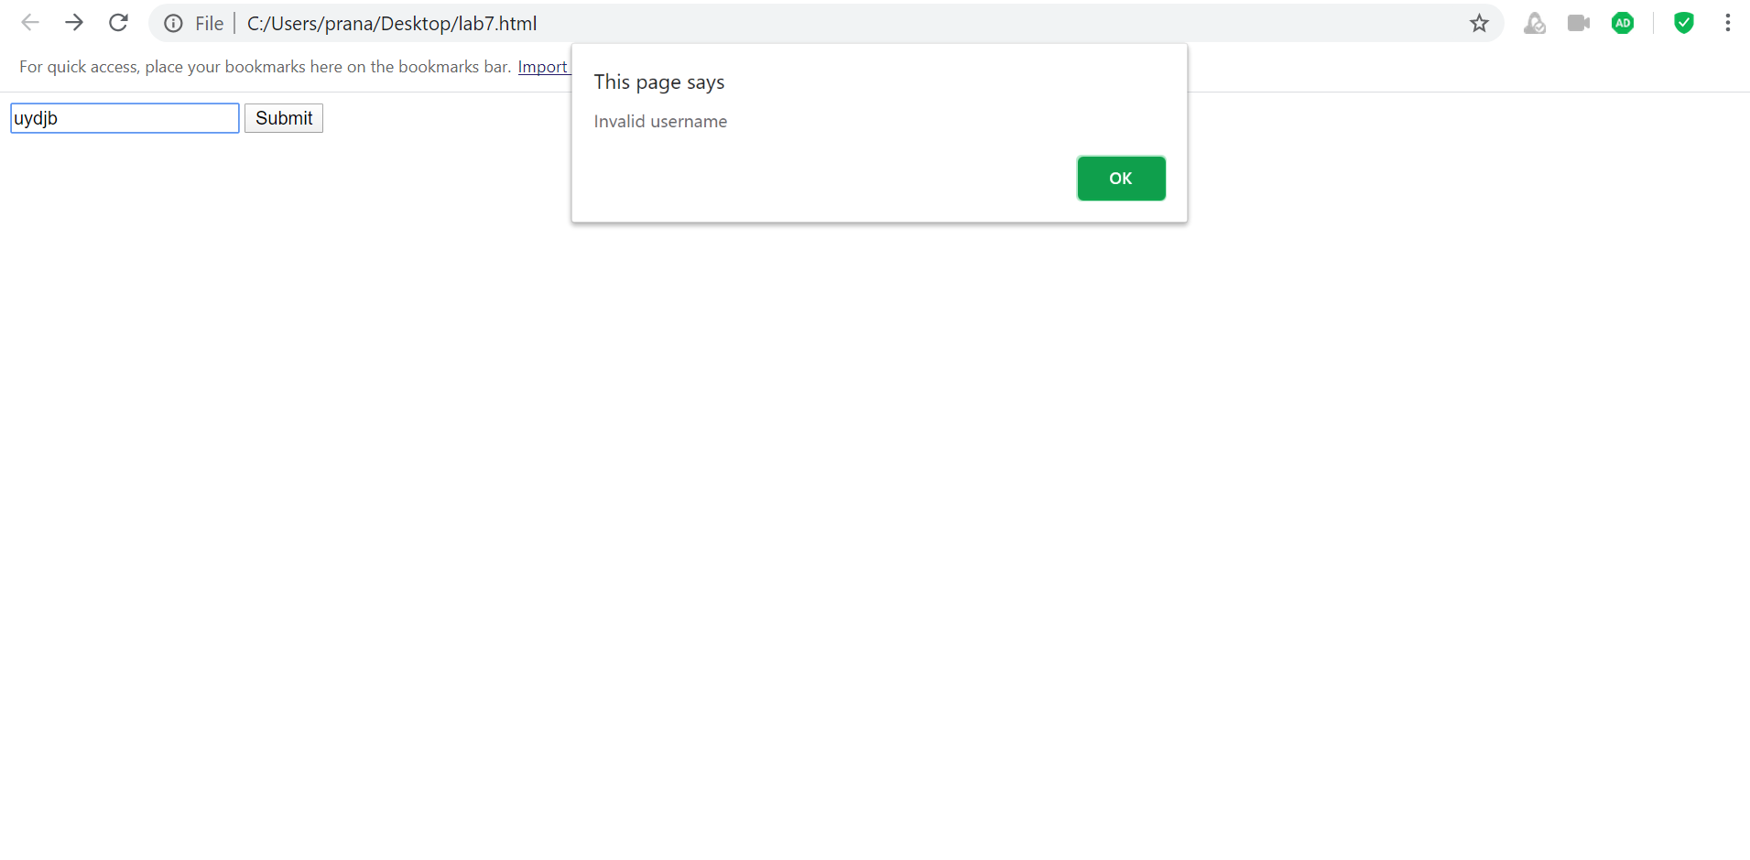

LAB 8

|  |
| --- |
| <!DOCTYPE  html> |
|  | <html> |
|  | <head> |
|  | <title>Registeration Form</title> |
|  | <style type="text/css"> |
|  | *{ |
|  | box-sizing: border-box; |
|  | text-align: center; |
|  | font-family: arial; |
|  | } |
|  | body{ |
|  | background-color: white; |
|  | background-attachment: fixed; |
|  | background-position: center; |
|  | background-size: cover; |
|  | /* background-repeat:round; */ |
|  |  |
|  | } |
|  | h1{ |
|  | color: black; |
|  | background-color: lightgray; |
|  | font-family: arial; |
|  | } |
|  | #form_box{ |
|  | margin-left: 10%; |
|  | margin-right: 10%; |
|  | padding: 5% 10%; |
|  |  |
|  | text-align: left; |
|  | border: 2px solid lightgray; |
|  | border-radius: 5px; |
|  | background-color: lightgray; |
|  | z-index: 999; |
|  | font-family: arial; |
|  | } |
|  | .mand{ |
|  | color: black; |
|  | } |
|  | h6{ |
|  | color: white; |
|  |  |
|  | z-index: 2; |
|  | font-family: arial; |
|  | } |
|  | input:link, |
|  | input:visited{ |
|  | border: 1px solid white; |
|  | } |
|  | input:hover, |
|  | input:active{ |
|  | border: 1px solid black; |
|  | } |
|  | #btn{ |
|  | border: 2px solid white; |
|  | z-index: 9999; |
|  | padding: 5px 5px; |
|  | border-radius: 5px; |
|  | transition: background-color 0.2s, color 0.2s; |
|  | } |
|  | #btn:hover, |
|  | #btn:active{ |
|  | background-color: rgb(900, 29, 29); |
|  | color: white; |
|  | border: 2px solid rgb(131, 0, 0); |
|  | border-radius: 5px; |
|  | padding: 5px 5px; |
|  | cursor: pointer; |
|  |  |
|  | } |
|  |  |
|  | textarea:link, |
|  | textarea:visited{ |
|  | border: 1px solid white; |
|  | } |
|  | textarea:hover, |
|  | textarea:active{ |
|  | border: 1px solid rgb(131, 0, 0); |
|  | } |
|  | </style> |
|  | <script type="text/javascript"> |
|  |  |
|  |  |
|  |  |
|  | var formExample = document.getElementById("form_box"); |
|  | formExample.submit(); |
|  |  |
|  | document.getElementById("form_box").onsubmit = function(e){ |
|  | var fieldValue=document.getElementById("name").value; |
|  | if(fieldValue==null || fieldValue== "") |
|  | { |
|  | e.preventDefault(); |
|  | alert("you must enter your name"); |
|  | } |
|  | var fieldValue=document.getElementById("email").value; |
|  | if(fieldValue==null || fieldValue== "") |
|  | { |
|  | e.preventDefault(); |
|  | alert("you must enter your email address"); |
|  | } |
|  | var fieldValue=document.getElementById("institution").value; |
|  | if(fieldValue==null || fieldValue== "") |
|  | { |
|  | e.preventDefault(); |
|  | alert("you must enter your institution name"); |
|  | } |
|  |  |
|  | var fieldValue=document.getElementById("stream").value; |
|  | if(fieldValue==null || fieldValue== "") |
|  | { |
|  | e.preventDefault(); |
|  | alert("you must enter your stream"); |
|  | } |
|  | var n=document.getElementById("sem").value; |
|  | if(!isNaN(parseFloat(n)) && isFinite(n)) |
|  | {e.preventDefault(); |
|  | alert("you must enter your semester"); } |
|  | var fieldValue=document.getElementById("con").value; |
|  | if(fieldValue==null || fieldValue== "") |
|  | { |
|  | e.preventDefault(); |
|  | alert("you must enter your contact no."); |
|  | } |
|  |  |
|  |  |
|  | } |
|  |  |
|  |  |
|  | function offconf() |
|  | { |
|  | document.getElementById("conf").innerHTML=" "; |
|  |  |
|  | } |
|  | function marq() |
|  | { |
|  | return ((new Date().getDate()).toString()); |
|  | } |
|  |  |
|  | </script> |
|  | </head> |
|  |  |
|  | <body style="background-color:red"> |
|  | <h1>Registration Form</h1> |
|  |  |
|  | <?php |
|  | $name = $email = $gender = $comment = $website = ""; |
|  |  |
|  | if ($_SERVER["REQUEST_METHOD"] == "POST") { |
|  | $name = test_input($_POST["name"]); |
|  | $email = test_input($_POST["email"]); |
|  | $institution = test_input($_POST["institution"]); |
|  | $course = test_input($_POST["course"]); |
|  | $stream = test_input($_POST["stream"]); |
|  | } |
|  |  |
|  | function test_input($data) { |
|  | $data = trim($data); |
|  | $data = stripslashes($data); |
|  | $data = htmlspecialchars($data); |
|  | return $data; |
|  | } |
|  | ?> |
|  |  |
|  | <form method="post" action="#after" id="form_box"> |
|  |  |
|  | <label for="name"><span class="mand">*</span>Name: </label> |
|  | <input type="text" id="name" name="name" required><br><br> |
|  |  |
|  | <label for="email"><span class="mand">*</span>Email-Id: </label> |
|  | <input type="email" id="email" name="email" required><br><br> |
|  |  |
|  | <label for="institution"><span class="mand">*</span>Institution: </label> |
|  | <input type="text" id="institution" name="institution" required><br><br> |
|  |  |
|  | <label for="dob"><span class="mand">*</span>Date of birth: </label> |
|  | <input type="date" id="dob" name="dob" required><br><br> |
|  |  |
|  | <label for="course"><span class="mand">*</span>Course </label> |
|  | <select id="course" name="course" required> |
|  | <option value="B.Tech">B.Tech</option> |
|  | <option value="M.Tech">M.Tech</option> |
|  | <option value="PhD">PhD</option> |
|  | </select> |
|  | <br><br> |
|  | <label for="stream"><span class="mand">*</span>Branch </label> |
|  | <input type="text" id="stream" name="stream" required> |
|  | &nbsp;&nbsp; |
|  | <br> |
|  | <br> |
|  | <label for="sem"><span class="mand">*</span>Semester: </label> |
|  | <input type="number" id="sem" max="8" min="1" value="3" required><br><br> |
|  | <label for="contact"><span class="mand">*</span>Contact Number:</label> |
|  | <input type="number" id="con" required><br><br> |
|  | <label for="skill"><span class="mand">*</span>Your Skills: </label> |
|  | <textarea id="skill" rows="7" cols="70" placeholder="Tell us your Skills in programming!"> |
|  | </textarea><br><br> |
|  | <input type="checkbox" id="check"> |
|  | <label for="check">Check if you want us to keep you updated.</label> |
|  | <br><br> |
|  | <p style="text-align: left; color: blue;">Fields marked with * sign are mandatory.</p> |
|  | <br> |
|  |  |
|  | <input type="submit" id="btn" value="Register" onmouseout="offconf();"><br> |
|  | <p id="conf"> </p> |
|  | </form> |
|  | <div id="after"> |
|  | <?php |
|  |  |
|  |  |
|  |  |
|  | echo "<h1> ".$name."</h1>"; |
|  | echo "<h3>You are pursuing ".$course." in ".$stream." at ".$institution."</h3>"; |
|  | echo "<h3>E-mail: ".$email."</h3>"; |
|  | ?> |
|  | </div> |
|  |  |
|  | </body> |
|  | </html> |

